Easy Infra-Red

Students often want to use remote control in their projects. Unless this can be done easily and reliably the students can either become discouraged or spend too much time on the remote control link and lose sight of the primary function of the project. Here is a simple approach to remote control that is reliable and also provides opportunities to learn some of the basics of electronics in a useful context.

Almost all domestic remote control uses infra-red (IR) light to send signals to the device to be controlled. Infra-red is light that is that is of a frequency that is too low, and so a wavelength that is too long, for our eyes to detect. Most IR electronic devices work with wavelengths of light between 850nm and 950nm, our eyes are sensitive to wavelengths between about 400nm and 700nm.

Infra-red beam alarm
A transmitter can produce an infra-red beam so that a receiver can sense when something passes through the beam for alarms or process control. The simplest broken beam alarm can be made using an infra-red LED as the source and a circuit containing an IR phototransistor as a receiver.

The transmitter is just a battery, resistor and IR LED like this:
A
K

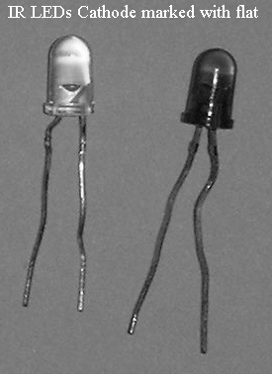
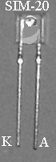
The IR LED has to be connected the correct way around just like an ordinary LED. Most IR LEDs have the familiar design with a flat on the body marking the cathode. Some LEDs use a more unusual design like the Rohm SIM-20ST from JPR electronics. The cathode is marked K and the anode (positive end) is marked A.

Calculating the resistor value
The value of the resistor can easily be calculated from the LED data. IR LEDs have a smaller voltage drop across them but typically use larger currents than ordinary LEDs.
Information on the characteristics of the IR LED is usually in the catalogue of the supplier.
Device | Supplier | Voltage, V_{f}/v | Maximum Current I_{max}/mA
TIL38 | Maplin YH70M | 1.7 | 100
Temic SIM20ST | JPR 850-362 | 1.25 | 50
Temic TSUS5400 | JPR 850-330 | 1.7 | 150
Siemens LD274 | RS 195-669 | 1.3 | 100
Siemens SFH409 | Maplin CY84F | 1.3 | 100
Example 1
Using a Temic TSUS5400 from JPR with a 3v battery
The LED has a maximum current of 150mA so choose something smaller say
I = 120mA = 120x10⁻³
Supply voltage from battery, V_{s} = 3v
Voltage across LED, V_{f} = 1.7v
Calculate the resistor using Ohm’s law

And calculate the power
So use a 12Ω 0.25W resistor.

Example 2
Using a Siemens SFH409 from Maplin with a 9v battery
The LED has a maximum current of 100mA so choose something smaller say
I = 80mA = 80x10⁻³
Supply voltage from battery, V_{s} = 9v
Voltage across LED, V_{f} = 1.3v
$R=\frac{V_{s}−V_{f}}{I}=\frac{\left(9−1\text{.}3\right)}{\text{80}×{\text{10}}^{−3}}=\text{96}Ω$Calculate the resistor using Ohm’s law

$P=\text{IV}=\text{80}×{\text{10}}^{−3}×(9−1\text{.}3)=0\text{.}\text{616}W$And calculate the power
So use a 100Ω 1W resistor.

You will notice that most phototransistors only have two legs: emitter and collector; the base ‘current’ is the light. The more IR light falls on the phototransistor the more current it conducts. The current creates a voltage across the resistor that can be used to turn on and off a device. The bigger the resistor the greater the sensitivity. However, the phototransistor responds to IR light from the sun and room lights so the sensitivity needs to be carefully adjusted so that the circuit ignores the background infra-red but responds to the light from the remote controller. This circuit should be built and the value of R1 adjusted so that voltmeter reads low (less than 1v) when the transmitter is off and the voltmeter reads high (more than 2v) when the transmitter is on.
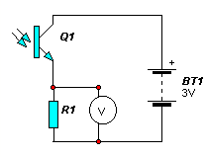

The value of R1 can be changed by swapping resistors or making R1 a variable resistor. One of my students recently found 100kΩ to be suitable for use with the Rohm RPM-20PB from JPR electronics.
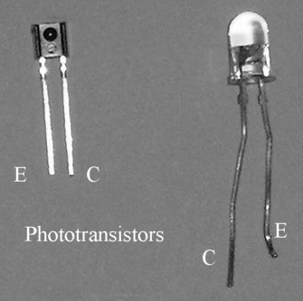
It is important to get phototransistor the correct way around. They are all NPN transistors so the collector (c) is positive. Some of the phototransistors are indistinguishable from IR LEDs so it is important to mark them as you unpack them, I used a small blob of paint on the base of the phototransistor to identify them. These phototransistors normally have the collector marked with the flat on the case so appear to be connected the opposite way round to an LED.

More recently I have tried to buy phototransistors that look nothing like LEDs (eg the Temic RPM-20PB from JPR 850-354) to avoid confusion and wasted time.

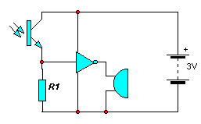
A NOT gate such as the 4069UB can be used to provide a signal that is either on or off. The NOT gate will control low current devices such as the miniature piezo buzzer from Rapid electronics (35-0115). Because the NOT gate is there the buzzer will be off whilst infra-red is being received and will come on when the infra-red light is not present. This can be used for a simple broken beam alarm. The transmitter is left permanently on pointing at the receiver. When some one passes between the remote control and the receiver the beam is broken and the buzzer sounds. This circuit can be improved by placing the sensor in a box and making a hole so that the light can only enter from one direction, this stops the sun and room lights from interfering with the operation of the circuit.

Simple remote control
To make transmitter into a remote-control just add a push switch to the transmitter circuit.

To use the remote control with output devices that require more current such as a motor for a buggy we need to add a MOSFET at the output of the NOT gate. The MOSFET will conduct a reasonable amount of current when it is provided with a high voltage at the gate. We exchange the positions of the phototransistor and resistor in the receiver so that the motor is on when the remote control is operated. Now the buggy moves when we press the button and stops when we let go.
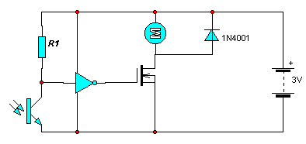

Modulated remote control
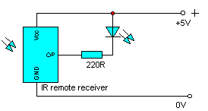
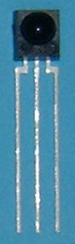The problem with the last circuit is that it is sensitive to background radiation and if it moves into direct sunlight it just will not stop. The remote control for the television does not appear to be sensitive to background IR light, this is because the signal is modulated. The IR from the remote controller is turned on and off 38000 times per second and the receiver is built to only respond to a 38kHz IR signal. We can obtain a much greater range and immunity from background radiation by using modulated IR. IR remote control receivers for use in TVs and other domestic equipment are easily and cheaply available as small devices (Rohm RPM-6938 from JPR, Sharp IS1U60 from Farnell or RS). The remote detector needs a supply voltage of 4.5-5.5v and produces a low output when 38kHz modulated IR falls on it. You can see how easy it is to use by connecting one up and putting an LED and resistor at the output. Point the remote controller for a TV at the device and the LED will flash when any button is pressed. You will see a different pattern of flashes depending on which button is pressed, this is due to different codes being sent for each button pressed.
1
3
2
1 - Output
2 - 0v
3 - 5v

To use a remote control receiver to operate a motor a few more components are needed. The detectors are sensitive to electrical noise, placing a 10μF capacitor, C1, across the supply pins and a diode in series with the positive supply makes the output reliable by filtering out electrical noise from the power supply. To stop the pattern of flashes and produce a steady output signal add a diode, capacitor and resistor to the output. This works because the capacitor, C2, is quickly charged to about 0v through the diode, D2, when the output of the detector goes low, but it takes a while to discharge back up to through the large resistor, R1, to produce a high output. We can use this to make a buggy with a much better range and performance but we do need the correct supply voltage for the remote control receiver, the voltage drop of about 0.6v across the diode on the positive supply pin will allow us to use a 6v battery. A spare remote controller from a TV or video recorder can be used to control the buggy.

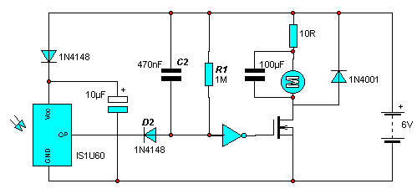
Often we do not want to have to hold down the switch on the remote controller to keep the device on. A remote control light switch would be best if we pressed the button on the remote controller once to turn the lights on and then pressed the button again to turn them off. This can be achieved with a D-type flip-flop like the 4013B wired up as a counting element. When a pulse goes into the clock of the flip-flop the output goes high, on the next pulse it goes low. Each pulse causes the output of the flip-flop to change state.
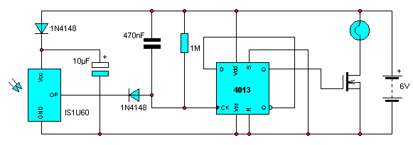
You can easily make your own modulated remote controller using a 555 timer circuit. The value of R1 will need adjusting to get exactly the right frequency this is best done in conjunction with the receiver set up with just an LED as in test circuit earlier. Alter R1 until you get a good range for the controller.
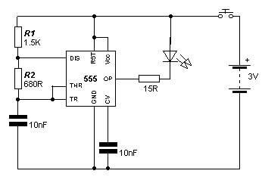
There are many possibilities for these circuits, they can only be used to control a single device. More than one device can be used if the flip flop in the last receiver circuit is replaced with a counter, then the devices several functions can be controlled by pressing the remote control button several times. To operate more than one device with a separate button for each function would require some kind of coding, this is usually achieved with specialist ICs or a microcontroller. This is beyond the scope of this article but there is plenty of information available on World Wide Web and in electronics magazines.

Useful contact details

Supplier | Telephone | Website
RS Components | 01536 201234 | http://rswww.com
Farnell | 0870 1200 200 | http://www.farnell.com
Rapid | 01206 751166 | http://www.rapid-electronics.co.uk
JPR Electronics | 01582 410055 | http://www.jprelec.co.uk
Maplin Electronics | 0870 2646000 | http://www.maplin.co.uk

My website has information on many of the components used in this article http://www.davidswinscoe.com

